
CENG 464 – Term Project (Phase 1)
“My Sweet Home (MSH) Smart Home System”
Design & Architecture Report
# | Name & Surname | Student ID | Role in Project (Phase 1)
1 | Khalid Abdi Mohamed | 220201994 | System Integrator & Final Workflow
2 | Abdullah Ahmed Abdi Moallim | 210201868 | Low-Level Requirements (LLRs)
3 | ANAS ABDULWAHAB MOALLIM MOHAMED | 210201958 | System Architecture & UML Diagrams
4 | Mohamed Abshir Jama | 220201967 | Device Design & Device Layer
5 | AMINE WACHICH | 210201942 | Modes, States & Behavioral Design

1. Introduction
1.1 Project Overview The "My Sweet Home" (MSH) project aims to design and develop a comprehensive smart home management system using C++ and Object-Oriented Programming principles. The system is designed to simulate a central control panel that manages various IoT devices, including lights, cameras, smart TVs, and safety detectors (smoke and gas). The core objective of this project is to demonstrate the practical implementation of industry-standard Design Patterns (such as Factory, State, and Facade) to solve complex architectural challenges.
1.2 Purpose and Scope The MSH system provides a text-based user interface (Menu) allowing users to add/remove devices, control power states, and switch between various home "Modes" (Normal, Evening, Party, Cinema). Additionally, the system includes critical safety and security features, such as automated alarm sequences for motion detection and fire hazards. The software is designed to be extensible, maintainable, and robust, utilizing a layered architecture that separates device logic from system control logic.
1.3 Technologies & Tools
- Language: C++ (ISO Standard)
- Design: UML Class Diagrams
- Version Control: Git (Branching and Integration)
- Build System: CMake / Replit

2. System Requirements
2.1. Low-Level Requirements (LLR)
Section 1: Menu & User Interaction
- LLR1: The system shall display the main menu containing all ten (10) options at startup. (Linked REQs: REQ1)
- LLR2: The system shall allow the user to select menu items using numeric keyboard input. (Linked REQs: REQ1, REQ3)
- LLR3: After completing any operation, the system shall automatically return to the main menu. (Linked REQs: REQ1)
- LLR4: When the user presses key "8", the system shall display the user manual. (Linked REQs: REQ2)
- LLR5: After displaying the manual, the system shall return to the main menu. (Linked REQs: REQ2)
- LLR6: When the user presses key "9", the system shall display the "About" information. (Linked REQs: REQ1)
- LLR7: Invalid menu inputs shall be handled by showing an error message and re-displaying the menu. (Linked REQs: REQ1, REQ3)
- LLR8: When the user selects "10 - Shutdown", the system shall terminate all operations and close safely. (Linked REQs: REQ1)
Section 2: Logging & Storage
- LLR9: The system shall create a log file at startup. (Linked REQs: REQ4)
- LLR10: The system shall append a log entry for every menu action performed by the user. (Linked REQs: REQ4)
- LLR11: Each log entry shall include a timestamp, action name, and device information when applicable. (Linked REQs: REQ4)
- LLR12: The system shall store all logs in a human-readable format such as JSON, XML, YAML, or plain text. (Linked REQs: REQ4)
- LLR13: The system shall close the log file only when the system is shut down. (Linked REQs: REQ4)
- LLR14: If the log file cannot be created, the system shall notify the user and continue running. (Linked REQs: REQ4)
Section 3: Device Management
- LLR15: All devices shall inherit from a base class named Device. (Linked REQs: REQ5)
- LLR16: Each device shall maintain a name (brand + model) and a data/status attribute. (Linked REQs: REQ5)
- LLR17: The system shall allow adding new devices via menu option "2 - Add Device." (Linked REQs: REQ5, REQ8)
- LLR18: The system shall allow adding multiple devices of the same type in one operation. (Linked REQs: REQ8)
- LLR19: When a new device is added, it shall inherit the configuration of an existing device of the same type. (Linked REQs: REQ10)
- LLR20: The system shall allow removing existing devices via menu option "3 - Remove Device." (Linked REQs: REQ5, REQ8)
- LLR21: Critical devices (smoke detector, gas detector, and alarm) shall not be removable by the user. (Linked REQs: REQ5, REQ6)
- LLR22: The system shall allow powering ON and OFF devices except critical devices (detectors and alarm). (Linked REQs: REQ6)
- LLR23: When a device fails, the system shall notify the user according to the selected notification method (Log/Alarm/SMS). (Linked REQs: REQ9)
- LLR24: Failure notifications shall be displayed on the screen in a readable format such as "SMS sent." (Linked REQs: REQ9)
Section 4: Modes Management
- LLR25: The system shall initialize in Normal Mode. (Linked REQs: REQ7)
- LLR26: Each mode shall specify predefined configurations for lights, TV, and music. (Linked REQs: REQ7)
- LLR27: Selecting a new mode via "6 - Change Mode" shall immediately apply all associated configurations. (Linked REQs: REQ7)
- LLR28: The system shall keep cameras and detectors powered ON in all modes. (Linked REQs: REQ7, REQ5)
- LLR29: The system shall display a confirmation message after switching to a new mode. (Linked REQs: REQ7)
Section 5: System States
- LLR30: The system shall initialize in Normal State at startup. (Linked REQs: REQ11)
- LLR31: When the system state changes, the previous state shall be stored in a state list. (Linked REQs: REQ11)
- LLR32: The user shall be able to switch to previous or next states via menu navigation. (Linked REQs: REQ12)
- LLR33: State transitions shall modify internal parameters such as performance level or refresh frequency. (Linked REQs: REQ11)
Section 6: Security System
- LLR34: The security system shall activate when security mode is enabled by the user. (Linked REQs: REQ13)
- LLR35: When motion is detected, the system shall activate the alarm for at least three seconds. (Linked REQs: REQ13)
- LLR36: After alarm activation, the system shall turn lights ON for two seconds. (Linked REQs: REQ13)
- LLR37: After lighting, the system shall notify authorities by printing "Calling police...". (Linked REQs: REQ13)
Section 7: Detection System
- LLR38: The detection system shall activate when smoke or gas levels exceed predefined thresholds. (Linked REQs: REQ14)
- LLR39: When activated, the detection system shall trigger the alarm until the user acknowledges the alert. (Linked REQs: REQ14, REQ15)
- LLR40: If the user does not acknowledge the alert sequence, the system shall print "Calling fire station..." and notify authorities. (Linked REQs: REQ16)

3. System Architecture & Class Design
The My Sweet Home (MSH) smart home system's architecture is built using a layered, modular design. To guarantee maintainability, scalability, and reusability, devices, managers, and controllers are kept apart. Additionally, this structure allows for future expansion without altering the general behavior of the system.
The fundamental elements of the system and their connections are shown in the class diagram below.
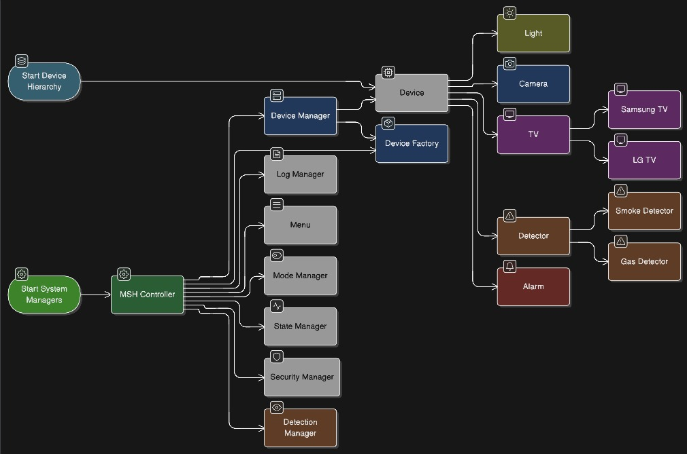

3.1 Layer Overview
The system is divided into two major layers
1. Device Layer
Contains all physical like devices:
- Lights
- Cameras
- Smart TVs (SamsungTV, LGTV)
- Smoke & Gas Detectors
- Alarm (critical device)
These devices inherit from a shared Device base class and are created using a DeviceFactory.
2. System Management Layer
Responsible for system logic, modes, states, security operations, and interactions between components.
It includes:
- MSHController
- DeviceManager
- LogManager
- Menu
- ModeManager
- StateManager
- SecurityManager
- DetectionManager

3.2 MSH Controller (Central Coordinator)
MSHController acts as the core controller of the entire smart home system.
It initializes managers, processes menu commands, coordinates device creation, and routes operations to the correct modules.
Responsibilities:
- Start system managers
- Coordinate interactions between managers
- Trigger device creation via DeviceFactory
- Manage system modes and states
- Provide a unified interface between user and system
This controller acts as a Facade, simplifying access to complex subsystems.

3.3 System Managers
Each manager handles a specific subsystem. This promotes high cohesion and low coupling, following clean architecture principles.
DeviceManager
Handles all device storage and lifecycle operations.
Key operations:
- addDevice(Device* d)
- removeDevice(Device* d)
- listDevices()
- getDevicesByType(type)
All managers interact with devices through this class.

LogManager
Responsible for logging all system events and actions.
Ensures traceability and debugging support.
Menu
Handles all user interactions and menu display.
Delegates functionality to the MSHController.
ModeManager
Controls user-selected modes:
- Normal
- Evening
- Cinema
- Party
Each mode defines a preset configuration for devices.
StateManager
Handles system performance states:
- Normal
- High Performance
- Low Power
- Sleep
States modify device behavior and system resource consumption.
SecurityManager
Manages security-related events:
- Intrusion detection
- Alarm control
- Emergency actions
DetectionManager
Coordinates smoke and gas detection events and triggers alarms when needed.

3.4 Device Hierarchy
Device (Abstract)
The base abstract class that defines shared features and structure for all devices.
Common Attributes:
- string name
- string type
- bool isActive
- bool isBroken
Common Methods:
- turnOn()
- turnOff()
- getStatus()
- setConfig()

Light
Concrete device for lighting functionality.
Camera
Smart camera with resolution and FPS properties.
TV (Abstract)
Shared structure for TVs.
SamsungTV / LGTV
Brand-specific TV subclasses with different model configurations.

Detector (Abstract)
Base class for all detectors.
SmokeDetector / GasDetector
Specialized sensors for safety operations.
Alarm
Critical device that cannot be removed and must always remain active.

3.5 DeviceFactory (Factory Pattern)
The system uses a Factory Design Pattern to create device objects dynamically.
This pattern improves extensibility because new device types can be added without modifying the main system logic.
Example behavior:
createDevice("Light") → returns new Light()
createDevice("SmokeDetector") → returns new SmokeDetector()

3.6 How Everything Connects (Workflow)
- User interacts with the Menu.
- Menu sends the command to MSHController.
- If a device is created → MSHController calls DeviceFactory.
- Factory returns a new device → added to DeviceManager.
- Managers (Mode, State, Security, Detection) access devices through DeviceManager.
- All actions are logged through LogManager.
This results in a clean, modular, and scalable architecture.

3.7 Design Patterns Used
Factory Pattern
Used by DeviceFactory to create devices.
State Pattern
Used by StateManager to represent system performance states.
Singleton Pattern (Optional)
MSHController can be implemented as a singleton.
Facade Pattern
MSHController simplifies access to complex subsystems.

4. Device Design
4.1. Base Device Class The Device class serves as the parent for all hardware components.
- Attributes: ID, Name (Brand + Model), IsActive (Power State), IsBroken (Status).
- Methods: turnOn(), turnOff(), testOperation().
- Constraint: Critical devices (Alarm, Detectors) override turnOff() to prevent accidental deactivation.
4.2. Concrete Device Classes
- Light: Includes specific attributes for Illumination Level (0-100%) and Color.
- Camera: Includes attributes for Resolution, FPS, NightVision, and MotionDetection status.
- Smart TV: Implemented as an abstract class with concrete derivations for SamsungTV and LGTV.
  - SamsungTV: Specialized implementation for Samsung protocols.
  - LGTV: Specialized implementation for LG protocols.
- Detectors:
  - SmokeDetector & GasDetector: Separate classes that constantly monitor environmental levels. They are always active in all modes.
- Alarm: A unique actuator class. It is a critical device that triggers sound alerts during security or safety breaches.
4.3. Device Creation (Factory Pattern) To manage the variety of devices, the system uses the Factory Method Pattern. The DeviceFactory class encapsulates the creation logic.
- Usage: When the user selects "Add Device" in the menu, the controller calls DeviceFactory::createDevice(type).
- Benefit: This allows the system to add new device types (e.g., a "Thermostat") in the future without modifying the core controller logic.

5. Modes & States Design
5.1. System Modes (Environment Configurations) Modes allow the user to configure multiple devices simultaneously with a single command.
- Normal Mode (Default): Lights ON, TV OFF, Music OFF.
- Evening Mode: Lights OFF, TV OFF, Music OFF.
- Party Mode: Lights ON, TV OFF, Music ON.
- Cinema Mode: Lights OFF, TV ON, Music OFF.
- Note: Cameras and Detectors remain active in all modes for safety.
5.2. System States (Performance Profiles) States manage the internal behavior and resource usage of the MSH system.
- Defined States: Normal, High Performance, Low Power, Sleep.
- State History: The system utilizes a Stack Data Structure to store previous states. This allows the user to "Go Back" to the previous state using the "Previous" menu option, satisfying Requirement 12.
5.3. Automated Sequences (Security & Safety) The system implements event-driven sequences described in the project scenario.
- Security Sequence (Intrusion):
  - Camera detects motion.
  - Alarm activates for 3 seconds.
  - Lights turn ON for 2 seconds.
  - System logs: "Calling Police".
- Detection Sequence (Fire/Gas):
  - Detector senses smoke or gas.
  - Alarm activates immediately.
  - System waits for user acknowledgment.
  - If no acknowledgment: Lights flash (1-second interval).
  - If there is still no response: System logs "Calling Fire Station".

6. System Integration & Workflow Design
6.1. Menu Structure Design
The Menu serves as the primary interface between the user and the system. It operates on an infinite loop, delegating user commands to the MSHController.
Menu Interaction Table
The following table maps user keyboard inputs to system actions, as defined in the high-level requirements.
Key | Action | Description | Controller Action
[1] | Get Home Status | Displays current Mode, State, and list of all active devices. | Calls DeviceManager::listDevices()
[2] | Add Device | Opens sub-menu to add (L)ight, (D)etector, (C)amera, or (T)v. | Calls DeviceFactory::createDevice()
[3] | Remove Device | Opens sub-menu to remove a device by ID. | Calls DeviceManager::removeDevice()
[4] | Power On | Turns on a specific device. | Calls Device::turnOn()
[5] | Power Off | Turns off a device (blocked for critical sensors). | Calls Device::turnOff()
[6] | Change Mode | Switches environment to (N)ormal, (E)vening, (P)arty, or (C)inema. | Calls ModeManager::setMode()
[7] | Change State | Switches performance to Normal, High Perf, Low Power, or Sleep. | Calls StateManager::setState()
[8] | Manual | Displays the user manual text. | Prints Manual.txt content
[9] | About | Displays project and developer information. | Prints Group Info
[10] | Shutdown | Safely terminates the system loop and closes logs. | exit(0)

6.2. Logging System Design
The logging system is designed to ensure traceability of all system events, satisfying Requirement 4.
- File Format: Text File (system_log.txt).
- Lifecycle: The log file is created/opened when the MSHController initializes and is safely closed when the "Shutdown" command is issued.
- Implementation: The LogManager class handles all file I/O operations to prevent race conditions.
Sample Log Output Format:
[TIMESTAMP] [LEVEL] [COMPONENT] Message
[2025-12-10 14:30:00] [INFO] [System] MSH System Started.
[2025-12-10 14:31:15] [INFO] [DeviceManager] Light (ID: 101) added to system.
[2025-12-10 14:35:12] [WARNING] [SecurityManager] Motion detected by Camera 1.
[2025-12-10 14:35:13] [ACTION] [SecurityManager] Alarm Triggered.
6.3. Integration Plan
The system uses a Centralized Control Architecture (Facade Pattern) to coordinate the subsystems.
Integration Workflow:
- Facade: The MSHController acts as the central hub. The Menu does not speak to devices directly; it speaks only to the Controller.
- Startup Sequence:
  - MSHController initializes LogManager.
  - MSHController initializes DeviceManager, ModeManager, StateManager.
  - System defaults to Normal Mode and Normal State.

- Event Handling:
  - User Events: Handled via the Menu loop.
  - Sensor Events: The DetectionManager runs a check during every loop iteration. If a detector (Smoke/Gas) triggers, the Controller interrupts the standard menu flow to execute the emergency sequence (Alarm -> Light -> Call)
6.4. Version Control (Git) Workflow
To ensure successful integration and bonus points, the team will adhere to the following Git strategy.
- Main Branch: Used for stable, production-ready code only.
- Dev Branch: The active integration branch where features are combined.
- Feature Branches: Each developer works on a specific branch (e.g., feature/device-classes, feature/menu-system).
- Commit Rules:
- Each member must build their own project successfully before pushing.
- Commit messages must be descriptive (e.g., [ADD] Implemented Camera Class).
- Screenshots of the commit history will be taken for the final presentation.

7. Assignment Table
(Developer Responsibility Matrix)
Developer | Role | Responsibilities / Components | Design Patterns
Khalid | Integrator | MSHController, Menu, LogManager, Integration Logic | Facade, Singleton
Anas | Architect | System Architecture, UML Class Diagrams | N/A
Moha | Devices | Device (Base), Light, Camera, TV, Detector, Alarm, DeviceFactory | Factory Method
Amin | Logic | ModeManager, StateManager, SecurityManager, DetectionManager | State Pattern
Abdullah | Requirements | Low-Level Requirements (LLR), Traceability Matrix | N/A

